Project 1 Report

Group #9

Zhengyang Tang, Li Zhu, Jiayi Xu, Zhuolin Yang

**3. Loading map**

We load the file and parse it into a map using

#attention: load sna first, then load igraph

#read data,need to set working directory first

edges1 <- read.table('roadNet-CA.txt')

em <- as.matrix(edges1) #save data in matrix

v1 <- em[,1] #Save the first column of data to v1

v2 <- em[,2] #Save the second column of data to v2

relations <- data.frame(from=v1,to=v2)

g<-graph.data.frame(relations,directed=TRUE)

Now g is our graph

**\* Map size reduction**

Firstly, we tried to reduce the map size by the method in the announcement. We deleted vertices with degree lower than or equal to certain number k.

The map size is acceptable when k is 10.

g <- g - V(g)[degree(g)<=10]

There were 2094 vertices and 184 edges left. Apparently, this method of map size reduction is not good since the graph is much too sparse after reduction. We decided to try another method.

Since deleting vertices with certain degree will result in drop of degree of vertices not being deleted and kept most of the remaining vertices connected, we tried to iteratively delete vertices with a very low degree. (here we delete vertices with degree lower than or equals to 4)

i <- 0

while(vcount(g)>5000){

g <- g - V(g)[igraph::degree(g)<=4]

i <- i+1

}

We keep deleting vertices whose degree lower or equals to 4 until there are less than 5000 of them remains. (graph with 5000 nodes is properly small for plotting) It takes 56 iterations to reduce the map size. Now the map has 4947 vertices and 16382 edges. This method is obviously better than the previous one.

* if we keep the loop running, the number of vertices left will converge to a number between 4000 and 5000.

**Plotting**

plot(g)

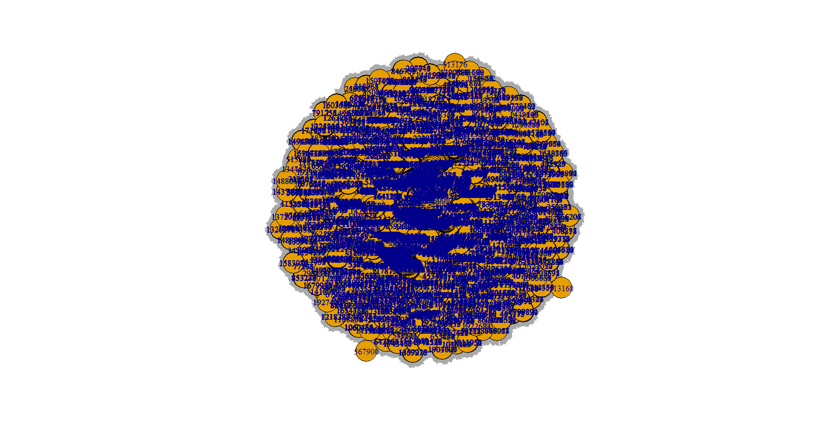

4.

5.

6.

7.